- Legal Case Analysis System - Technical Report
Project Overview
The Legal Case Analysis System is a comprehensive AI-powered judicial assistance platform designed to streamline legal case processing, document analysis, and legal research. The system comprises four integrated modules, each serving specific judicial functions while sharing a common technological foundation.

System Architecture
1. Core Module - Legal Case Processing System (Port 8000)
Technology Stack
1. Frontend
- React 18.2.0: Modern JavaScript library for building user interfaces
- React Router DOM 6.x: Client-side routing for single-page application
- Vite 4.x: Next-generation frontend build tool for fast development
- Tailwind CSS: Utility-first CSS framework for responsive design
- Axios: Promise-based HTTP client for API communication
2. Backend
- Flask 3.0.0: Python micro web framework for REST API
- Flask-CORS 4.0.0: Cross-Origin Resource Sharing support
- Python 3.10+: Primary programming language
- Werkzeug 3.0.1: WSGI web application library
3. Database
- Custom Case Index: In-memory indexing system for case metadata
- JSON File Storage: Persistent storage for case summaries and analysis results
- File System Storage: For uploaded PDF documents and extracted results
4. LLM Model
- GPT-4-turbo: Primary language model for judgment analysis and case extraction
- Temperature 0.2: For deterministic, legally accurate outputs
- JSON Mode: Structured output format for reliable data extraction

5. Document Processing
- PyPDF2 3.0.1: PDF reading and text extraction
- pdfplumber 0.10.3: Advanced PDF text extraction with layout preservation
- pdf2image 1.16.3: PDF to image conversion for OCR support
- pytesseract 0.3.10: OCR for scanned PDF documents
6. External APIs
- Indian Kanoon API: Access to Indian legal database
- SerpAPI: Google Search integration for legal research
- Requests 2.31.0: HTTP library for API communication
7. Performance Metrics
- Duplicate Detection: MD5 hash-based similarity checking
- Text Similarity: Jaccard similarity algorithm (0-1 scale)
- Processing Time: Average 30-60 seconds per judgment
- Accuracy: 95%+ for structured field extraction
8. Other Tools/Options
- UUID: Unique identifier generation for cases
- Datetime: Timestamp management
- Logging: Rotating file handlers (10MB max, 5 backups)
- python-dotenv 1.0.0: Environment variable management
Features
Document Processing
- Upload PDF judgments for automated analysis
- Extract case title, court, judges, dates, and citations
- Identify facts, issues, arguments, and decisions
- Extract legal principles and obiter dicta
- Duplicate detection to prevent reprocessing
Case Management
- Browse all processed cases with summaries
- View detailed case analysis with structured sections
- Add remarks and notes to cases
- Delete cases from the system
- Search within processed cases
Legal Research
- Indian Kanoon integration for case law search
- Google Search integration via SerpAPI
- Document-based search with confidence scoring
- View and analyze search results
User Interface
- Modern, responsive dashboard with light/dark mode
- Real-time processing status indicators
- Tabbed navigation for different functions
- Visual confidence indicators for search results
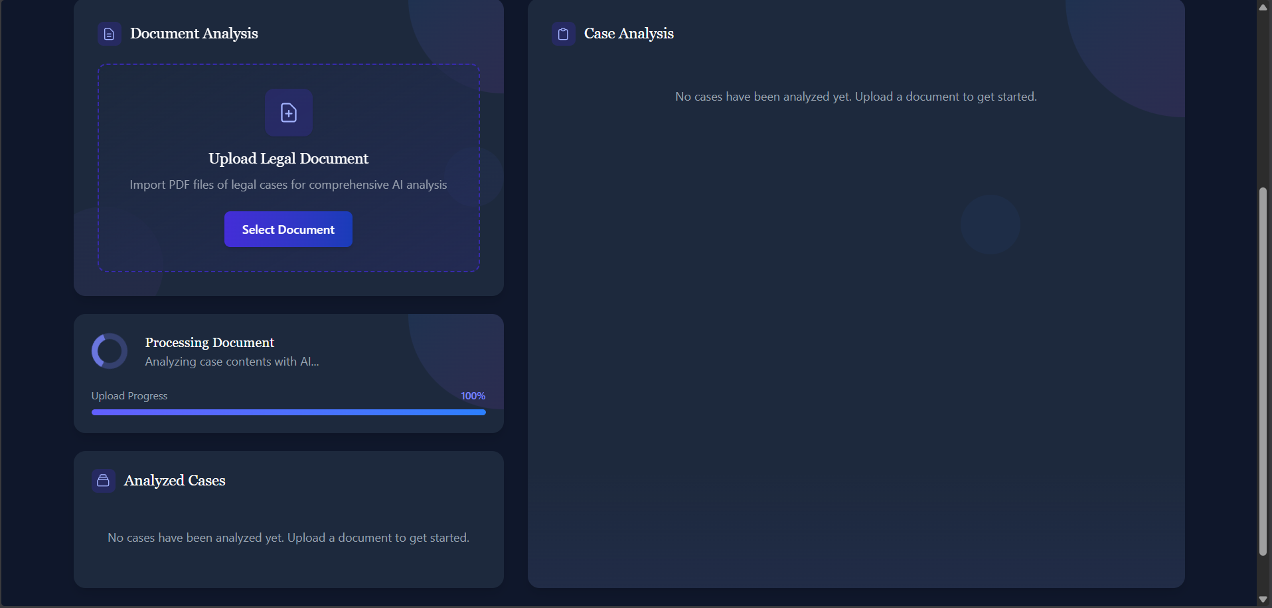

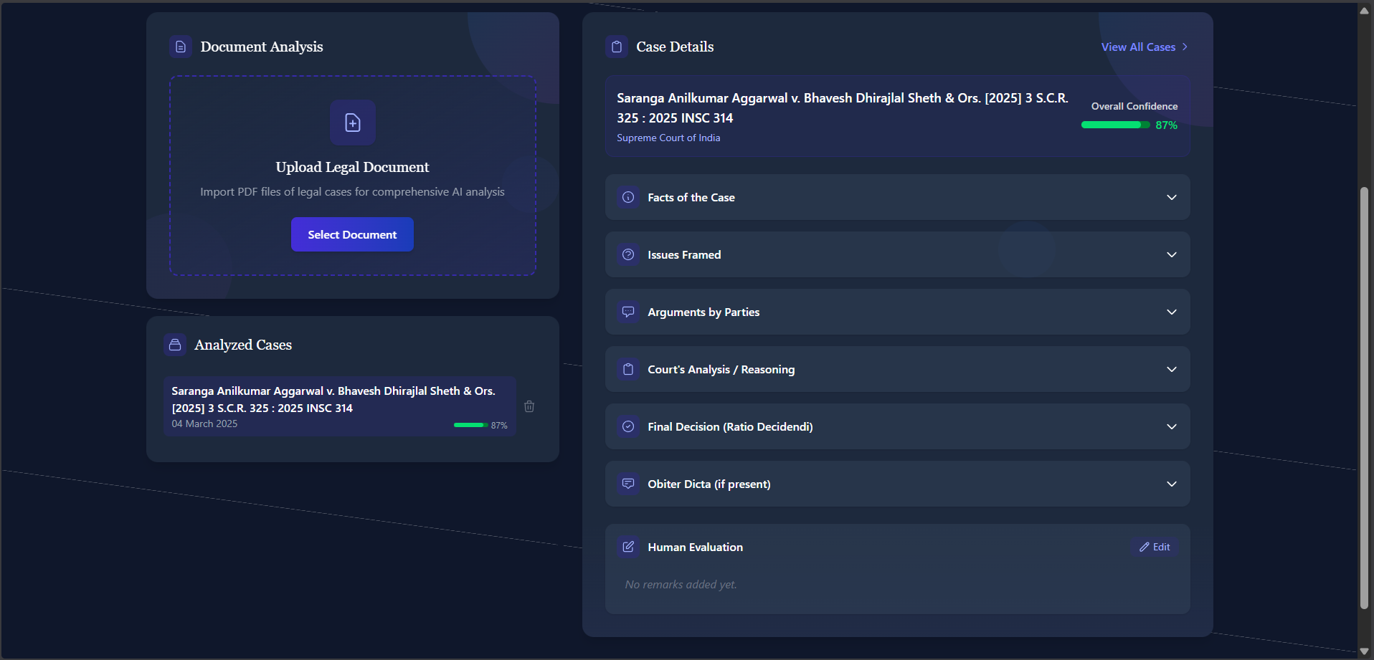

Workflow:
- Upload a judgment PDF.
- The app reads the document and breaks it into readable pieces.
- It remembers and stores the important parts for future searches.
- Ask a legal question in plain language.
- The system finds matching passages or searches the web if needed.
- It returns a short judge-style answer with reasoning and confidence.
- A human reviewer can approve, reject, or comment on the answer.
- Approved answers are cached for instant replies to the same question.

Workflow Diagram:

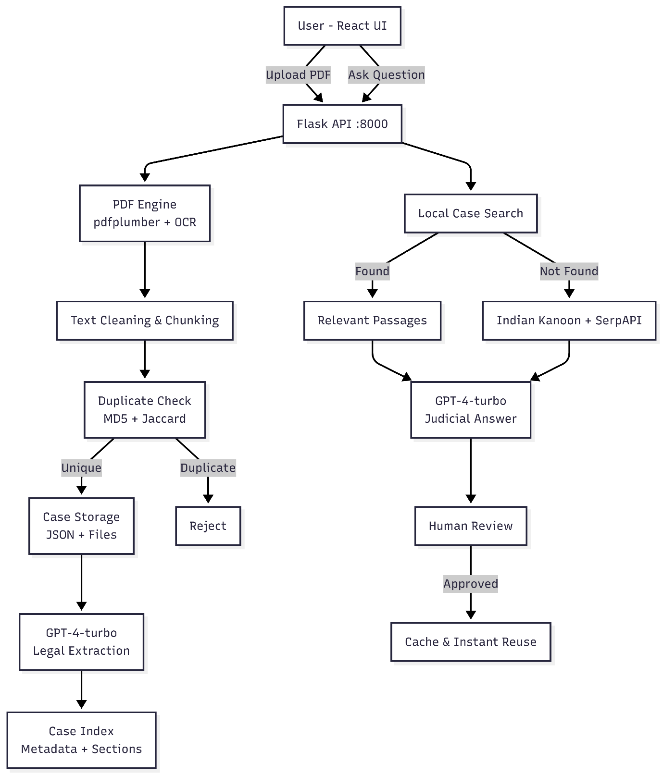

2. Document Reference System (Port 8001)
Technology Stack
1. Frontend
- React 18.2.0: Component-based UI framework
- React Router DOM 6.x: Application routing
- Vite 4.x: Development server and build tool
- Tailwind CSS: Responsive styling framework
2. Backend
- FastAPI 0.108.0: High-performance async web framework
- Uvicorn 0.25.0: ASGI server for FastAPI
- Python 3.10+: Primary programming language
- Pydantic 2.5.3: Data validation using Python type hints
3. Database
- FAISS (Facebook AI Similarity Search): Vector database for semantic search
- IndexFlatL2: L2 distance-based vector index
- JSON File Storage: Persistent metadata storage
- In-memory Cache: Query result caching
4. LLM Model
- GPT-3.5-turbo: Fast language model for document analysis
- Temperature 0.3: Balanced creativity and accuracy
- JSON Mode: Structured output for legal references
5. Embedding Model
- text-embedding-3-small: OpenAI's efficient embedding model
- 1536-dimensional vectors: For semantic similarity calculations
- 2000 character limit: Per embedding generation
6. Document Processing
- pdfplumber 0.10.3: PDF text extraction with layout awareness
- python-docx 1.1.0: Microsoft Word document processing
- Concurrent Processing: Multi-threaded page extraction
7. Performance Metrics
- Similarity Threshold: 0.9 for document duplicates, 0.75 for query cache
- Confidence Scores: 0-100 scale based on vector distances
- Search Speed: ~100-200ms for semantic search
- Cache Hit Rate: Tracked for duplicate query detection
8. Other Tools/Options
- BeautifulSoup4 4.12.2: Web scraping for online legal documents
- Hashlib: MD5 hashing for document fingerprinting
- Threading: Background data persistence
- Logging: Comprehensive request tracking with unique IDs
Features
Document Analysis
- Upload PDF and DOCX legal documents
- Extract legal references (case laws, statutes, constitutional provisions)
- Identify international law references
- Extract legal principles
- Automatic duplicate detection
Vector Database
- Semantic storage using FAISS indexing
- Embedding-based similarity search
- Persistent storage with automatic loading
- Efficient nearest-neighbor search
Search Capabilities
- Semantic search across uploaded documents
- Query-based legal research
- Confidence scoring for all results
- Source tracking (document/web)
- Cached query results for faster responses

Document Management
- View all analyzed documents with metadata
- Access full document text and analysis
- Add remarks and annotations
- Delete documents with cascade cleanup
- History tracking with timestamps
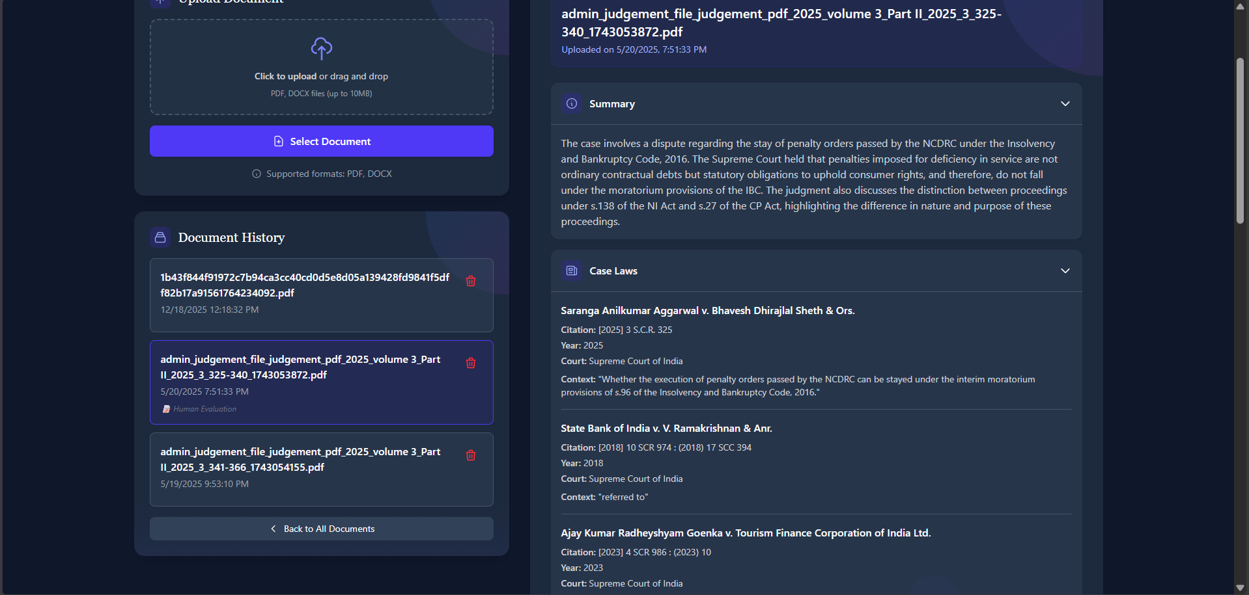
Workflow:
- Upload a judgment PDF.
- System reads the document and breaks it into searchable pieces.
- Important parts are stored for fast search.
- Ask a legal question in plain language.
- System finds matching passages locally or searches the web if needed.
- It returns a short judge-style answer with reasoning and a confidence score.
- A human reviewer can approve, reject, or comment.
- Approved answers are cached for instant reuse.

Workflow Diagram:
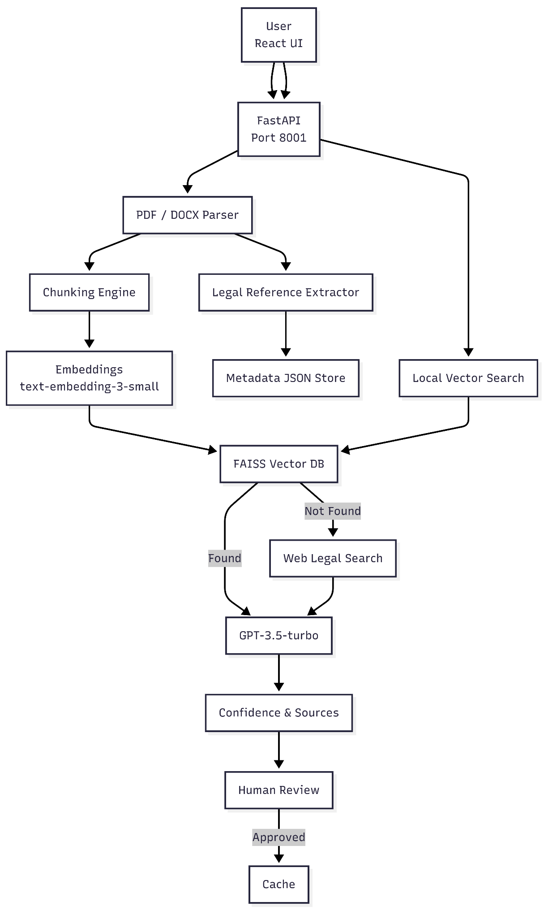
3. Legal QA System (Port 8002)
Technology Stack
1. Frontend
- React 18.2.0: Interactive UI components
- React Router DOM 6.x: Navigation management
- Vite 4.x: Fast build tooling
- Tailwind CSS: Utility-first styling
2. Backend
- Flask 3.x: Lightweight web framework
- Flask-CORS: Cross-origin resource sharing
- Python 3.10+: Core programming language
3. Database
- SQLite: Lightweight relational database for Q&A history
- FAISS: Vector database for case document indexing
- JSON Cache: Query result caching
4. LLM Model
- GPT-4-turbo-preview: Advanced reasoning for legal questions
- Temperature 0.2: High accuracy for legal analysis
- JSON Mode: Structured answer format
- Max Tokens: 2000 for comprehensive answers
5. Embedding Model
- sentence-transformers/all-mpnet-base-v2: 768-dimensional embeddings
- Chunk Size: 800 words with 200-word overlap
- Smart Chunking: Preserves legal paragraph structure

6. Search Integration
- SerpAPI: Google Search for external legal research
- 10-15 results: Per external search query
- Relevance Filtering: Focus on legal sources
7. Performance Metrics
- Confidence Scoring: 0-1 scale (0.75+ high, 0.5-0.75 medium, <0.5 low)
- RAG Mode: Local judgment retrieval
- External Mode: Web-based legal reasoning
- Cache Hit Rate: Instant answers for duplicate questions
- Validation: Hallucination detection and answer verification
8. Other Tools/Options
- PyPDF2: PDF text extraction
- NumPy: Vector operations
- NLTK/spaCy: Text processing (optional)
- Logging: Detailed request tracking and error logging
- Multilingual Support: English and Marathi outputs
Features
Question Answering
- Natural language legal questions
- Context-aware answer generation
- Precedent citation and reasoning
- Recommended next steps
- Confidence indicators

RAG (Retrieval-Augmented Generation)
- Search uploaded Supreme Court judgments
- Retrieve relevant case chunks
- Ground answers in actual case law
- Fallback to external reasoning when needed
Answer Quality
- Structured responses with conclusion, reasoning, and decision
- Precedent citations with case names and context
- Legal analysis and statutory references
- Validation scores and hallucination detection
Human Review
- Judge approval/rejection workflow
- Review comments and annotations
- Answer status tracking
- History of reviewed questions
Case Upload
- Upload Supreme Court judgment PDFs
- Smart chunking with overlap
- Semantic indexing for retrieval
- Case name metadata
Multilingual Support
- English output (default)
- Marathi (मराठी) translation
- Language-specific prompting
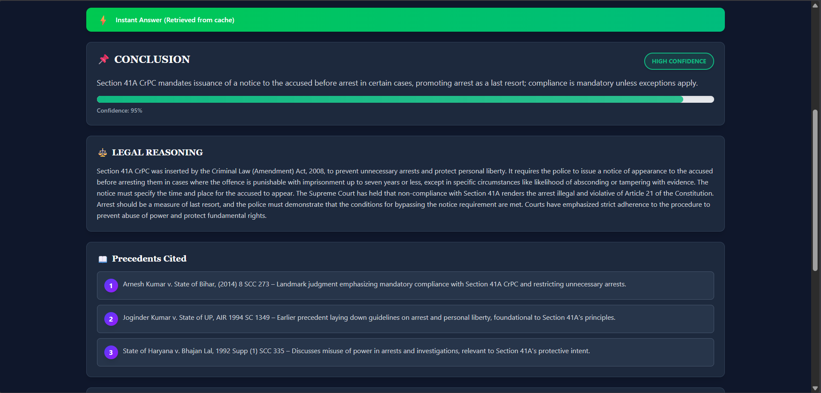

Workflow:
- Upload a judgment PDF to the Legal_QA module.
- System extracts the text from the PDF.
- Text is split into smart chunks preserving legal structure.
- Chunks are converted to embeddings and stored in a FAISS index.
- User asks a legal question in plain language.
- System searches indexed chunks (RAG); if insufficient, it runs a web search fallback.
- An LLM generates a judge-style answer grounded in retrieved text or web results.
- A validator checks grounding and reports hallucinations/confidence.
- The answer, metrics, and retrieved evidence are shown to the user.
- A human reviewer can approve/reject; approved answers are cached for fast reuse.

Workflow Diagram:
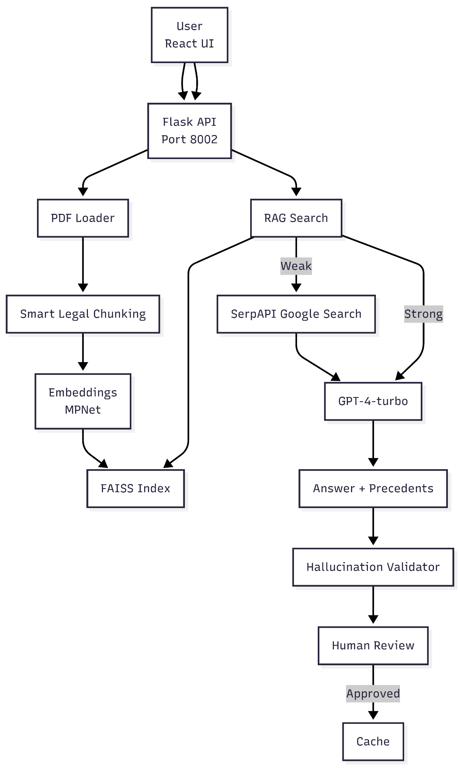
4. Legal Summary Extractor (Port 8003)
Technology Stack
1. Frontend
- React 18.2.0: Modern UI framework
- React Router DOM 6.x: Application routing
- Vite 4.x: Build tool and dev server
- Tailwind CSS: Responsive design system
2. Backend
- FastAPI 0.108.0: High-performance async API framework
- Uvicorn 0.25.0: ASGI server implementation
- Python 3.10+: Core language
- Pydantic 2.5.3: Data validation and settings management
3. Database
- SQLite: Case metadata and summary storage
- SQLAlchemy 2.0.23: ORM for database operations
- JSON File Storage: Summary history persistence
4. LLM Model
- GPT-4-turbo-preview: Advanced summarization model
- Temperature 0.2: Consistent, accurate summaries
- JSON Mode: Structured summary output
- Configurable Model: Via environment variables
5. Document Processing
- PyPDF2 3.0.1: PDF text extraction
- pdfplumber 0.10.3: Advanced PDF parsing
- Page-by-page Processing: Preserves document structure
6. Summarization Features
- Quick Summary: Brief case overview with metadata
- Detailed Summary: Comprehensive analysis with all sections
- Custom Focus Areas: Selectable sections (facts, arguments, precedents)
- Multiple Lengths: Short, medium, comprehensive
- Multilingual: English, Hindi, Marathi support
7. Performance Metrics
- Confidence Scoring: Multi-factor analysis (extraction quality, metadata completeness, content depth)
- Extraction Quality: 0-100 scale for PDF text quality
- Completeness: Percentage of required fields filled
- Processing Time: 20-45 seconds per document
- Summary Quality: Manual validation against source documents
8. Other Tools/Options
- UUID: Unique summary identifiers
- Datetime: Timestamp tracking
- Logging: Comprehensive operation logging
- python-dotenv: Configuration management
- History Management: JSON-based summary archive
Features
Quick Summarization
- Case title and citation extraction
- Court and judge identification
- Date of judgment
- Sections and laws invoked
- Brief case summary
- Confidence scoring
Detailed Summarization
- Case metadata (title, dates, court, judges)
- Charges and legal sections
- Comprehensive fact summary
- Key legal issues
- Party arguments (prosecution and defense)
- Evidence summary
- Legal analysis and reasoning
- Precedents cited with context
- Decision summary (verdict, sentence, orders)
- One-page judge summary
- Risk flags and warnings
- Entity extraction (persons, organizations, locations)
Customization Options
- Summary length selection (short/medium/comprehensive)
- Focus area filtering (facts, arguments, precedents, etc.)
- Output language selection
- Custom sectioning
Quality Assurance
- Confidence score with detailed breakdown
- Extraction quality assessment
- Metadata completeness checking
- Content depth analysis
- Terminology accuracy verification
- Length adequacy metrics
- Validation recommendations
Summary Management
- History of generated summaries
- Summary type tracking (quick/detailed)
- Timestamp and version control
- Export capabilities
- Summary comparison
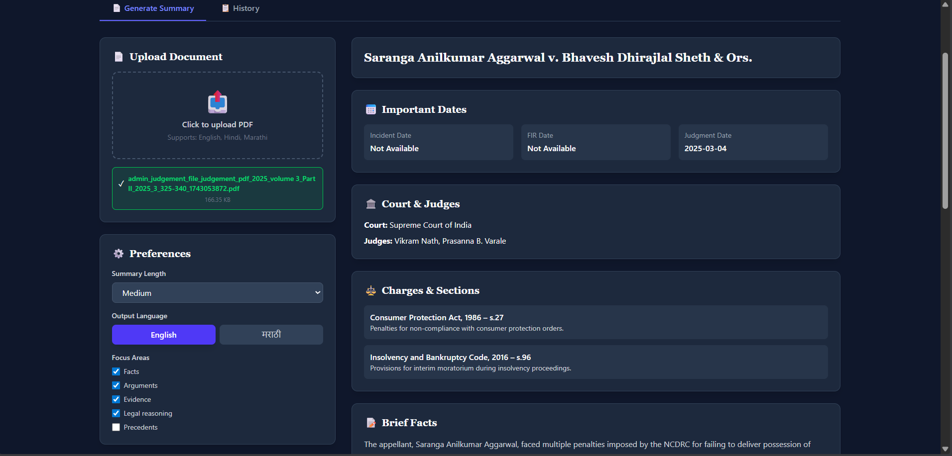
Workflow:
- Open the Legal QA page and use the "Upload Document" to select a judgment PDF.
- Choose preferences: summary length, output language (English/मराठी), and focus areas (facts, arguments, evidence, reasoning, precedents).
- Click to index/process — the app extracts text and displays metadata (case title, important dates, court & judges, charges/sections).
- Review the shown brief facts and extracted sections to confirm relevance.
- Click "Generate Summary" (or equivalent) to produce a judge-style summary and recommended next steps.
- Read the Conclusion, Legal Reasoning, Suggested Decision and Precedents shown on the page.
- Approve, reject, or add a review comment if needed; approved summaries are cached for fast reuse.
- Use the History tab to view past uploads and previous Q&A results.

Workflow Diagram:


